Deploying a Web Application on AWS EC2 Using Apache Web Server

Introduction
This project demonstrates how to deploy a web application on AWS EC2 using the Apache2 web server. It provides hands-on experience in launching a cloud server, configuring security, connecting via SSH, and hosting a web application that can be accessed through a web browser.
Step 1: Create an EC2 Instance
- Log in to the AWS Management Console
- Go to EC2 → Launch Instance
- Select Ubuntu Server 20.04 or 22.04 LTS
- Choose instance type t2.micro
- Create or select an existing key pair
- Launch the instance
- Wait until the instance state shows Running
Output: EC2 instance successfully created and running
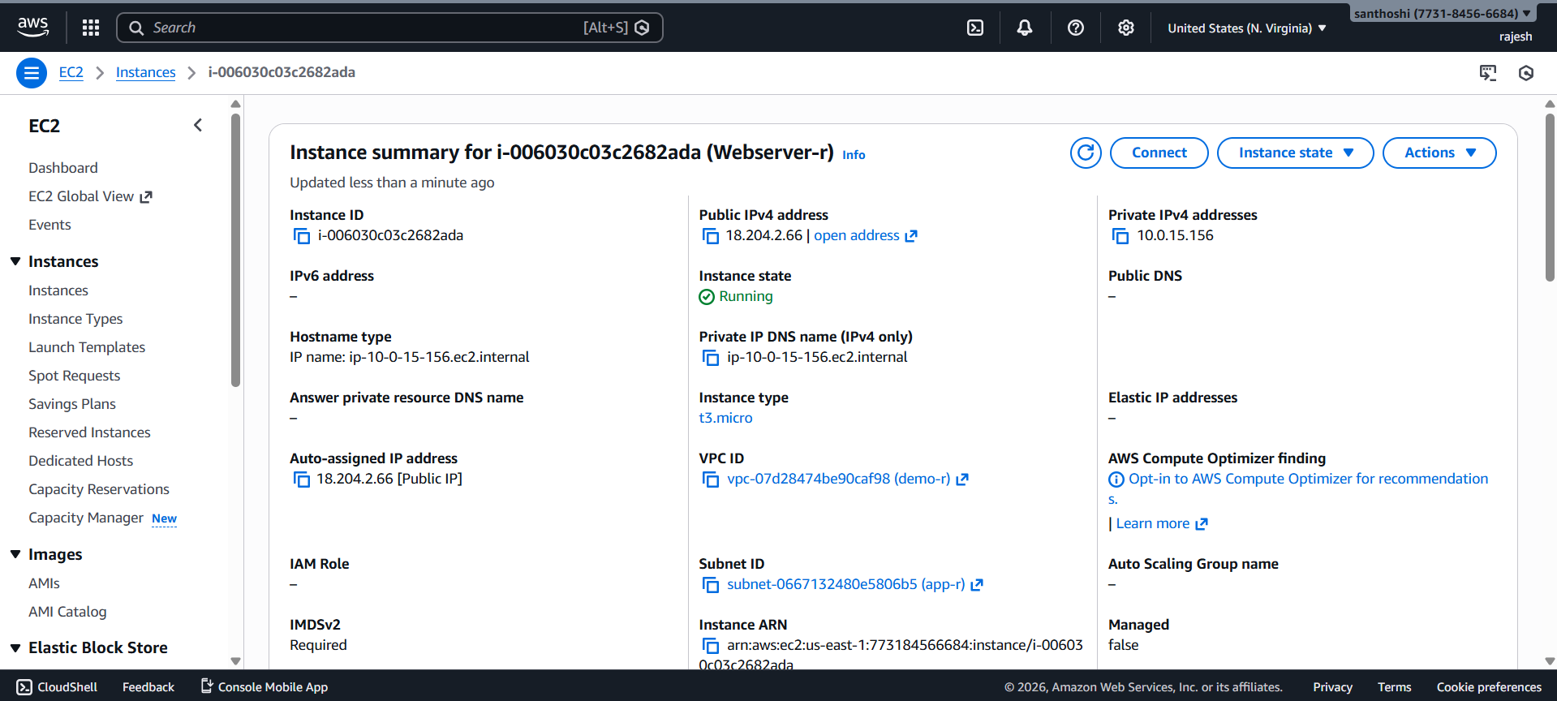
Step 2: Configure Security Group
- Open the EC2 instance details
- Go to Security → Security Groups → Edit Inbound Rules
- Add the following rules:
Type | Port | Source
SSH | 22 | My IP
HTTP | 80 | 0.0.0.0/0
- Save the rules
Output: SSH and HTTP access enabled
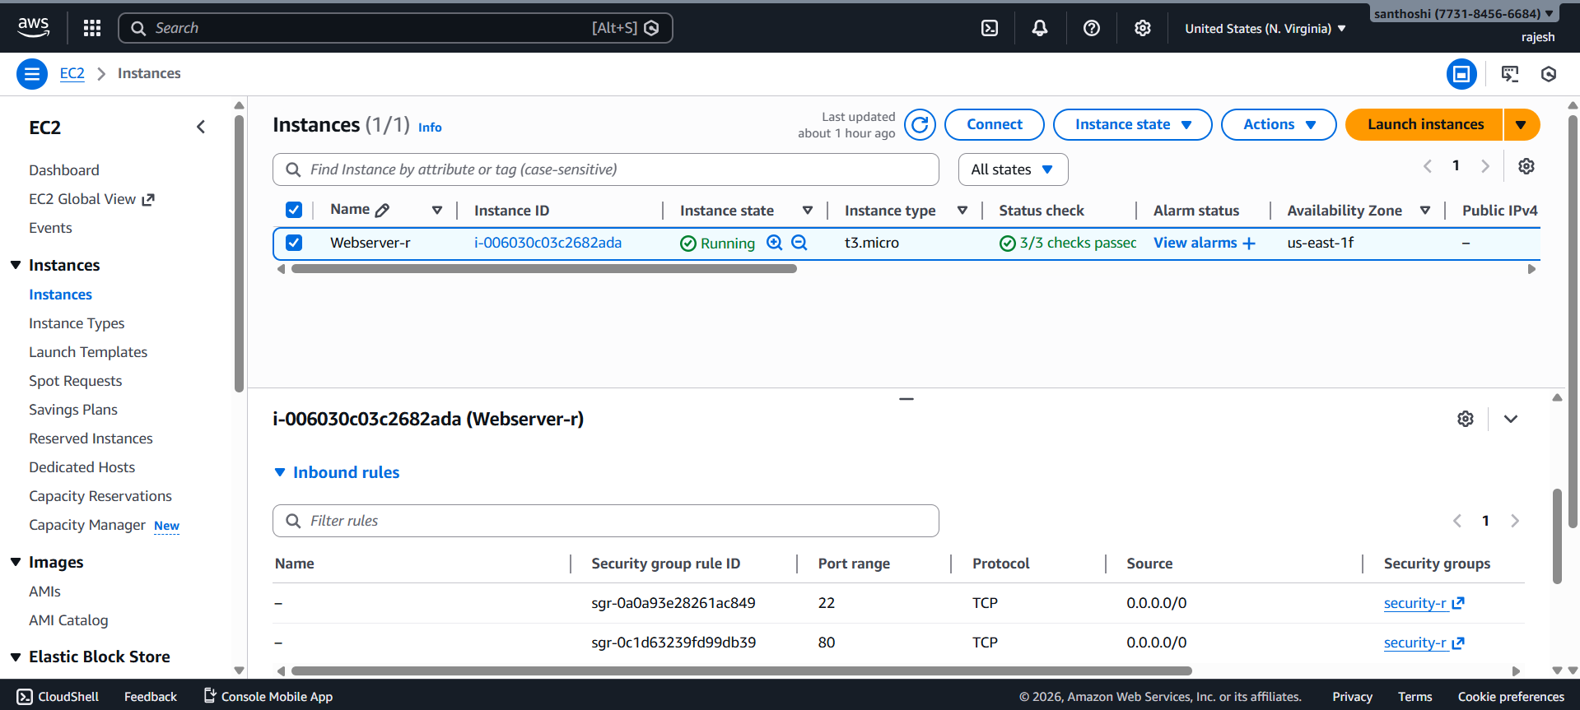

Step 3: Connect to EC2 Using SSH
- Copy the Public IPv4 Address of the EC2 instance
- Open terminal (Linux/macOS) or PuTTY (Windows)
- Run the SSH command:
>> ssh -i "linux-r.pem" ubuntu@18.204.2.66
- Confirm successful login
Output: Connected to EC2 instance via SSH

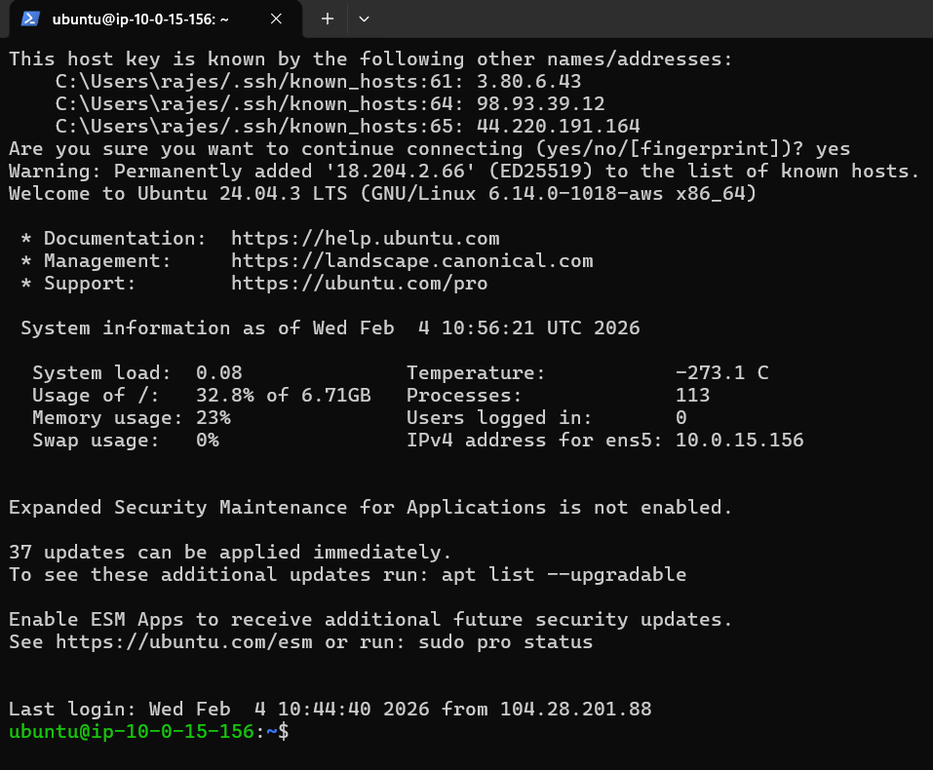

Step 4: Install Apache Web Server
- Update system packages:
>> sudo apt update
- Install Apache2:
>> sudo apt -y install apache2
- Start Apache service:
>>sudo systemctl start apache2
- Check Apache status:
>> sudo systemctl status apache2
Output: Apache2 service running successfully

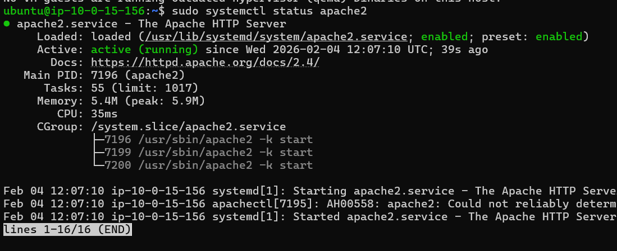

Step 5: Test Apache in Browser
- Open a web browser
- Enter the EC2 Public IP Address
- Verify the Apache default page appears
Output: Apache default web page displayed

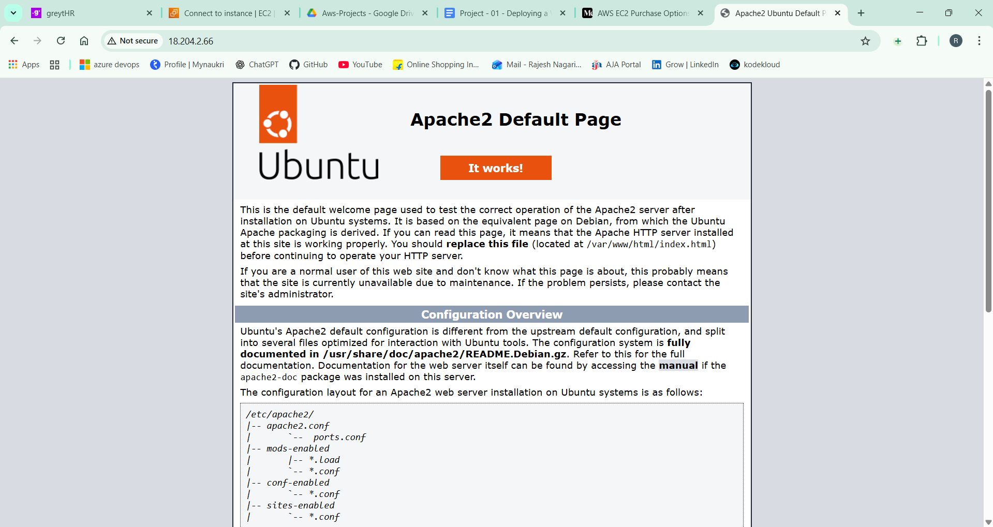

Step 6: Deploy Sample Web Application
- Go to Apache web root directory:
>> cd /var/www/html
- Edit the index.html file:
>> sudo nano index.html
Paste the following code:
<!DOCTYPE html>
<html>
<head>
<title>My AWS EC2 Web App</title>
</head>
<body>
<h1>Welcome to My EC2 Web Server</h1>
<p>Apache2 is running successfully on AWS!</p>
</body>
</html>
- Save and exit the file
- Refresh the browser
Output: Custom web application page displayed
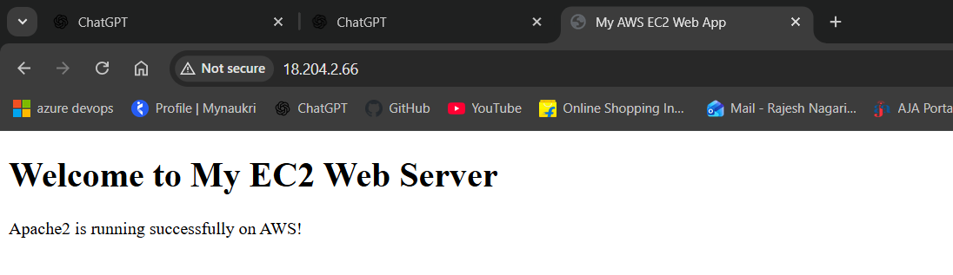
Conclusion
This project demonstrates how to launch an EC2 instance, configure security rules, install Apache, and deploy a basic web application on AWS. It provides hands-on experience with cloud infrastructure and web server management.

